Study notes:

Lecture 01

* Computer vision relates to – neuroscience 40%, cognitive sciences 60%, (graphics, algorithms, system, theory, …) 10%, information retrieval 10%, machine learning 90%, image processing 10%, robotics 10%
* Ways to detect an object in an image
  + Template matchine – naïve approach. Only works well when the image is exactly the same
  + Bag-of-words representation – map pixels into a more robust form, then compare those mapped forms, finally, select the closest image map
    - Computer edges, compute color histograms, gradients, HOG, SIFT, …
    - Uses edges helps to identify shapes. You also have a map of how many times that edge shows up in the image
* Face recognition was a breakthrough technology 15 years ago

Lecture 02

* Linear classifier
  + A straight line that
* Logistic regression
  + Is a single neuron, a neural network goes back to update as it learns more
  + Used to solve the classification problem
* Loss function for logistic regression
  + Calculates how many of the tests are classified incorrectly
* Cost function for logistic regression
  + Tells how good the algorithm is currently doing ( at the current iteration)
* Gradient decent algorithm
* Computation graph
* Derivatives for logistic regression
* ~~Implementing logistic regression in python~~
* Sigmoid
  + Takes any parameter and returns a value between 0 and 1
  + Good for neurons with binary classifiers
  + Is used at the end
* Handling multiple classes in neural networks more than isCat notCat
* One vs all
  + You run binary classifier on all classes and take the one with the highest likelihood
* Softmax regression
  + Define a new cost function and derive all the weight update rules according to that cost function
  + Is a replacement for sigmoid. Use the following instead of sigmoid
  + 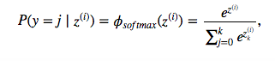
* ReLU
  + a = g(z) = max(0,z)
  + used in the intermediate stages
* know the derivatives for the activation functions
* Neural networks
* Fully connected (FC) Neural Network
  + Means that there is a weight for every parameter in the network
  + Learn how to calculate dimensions for W
  + All neurons are connected to each other

Lecture 03/4

* Deep vs shallow
* Deep NN notation
* Hyperparameters
  + **Hyperparameters** are the **variables which determines the network structure**(Eg: Number of Hidden Units) and the **variables which determine how the network is trained**(Eg: Learning Rate).
* Forward vs backward computation
  + Forward step – loss function, functions computing prediction, cost, then gradients
    - Continuously computing chain rule
  + 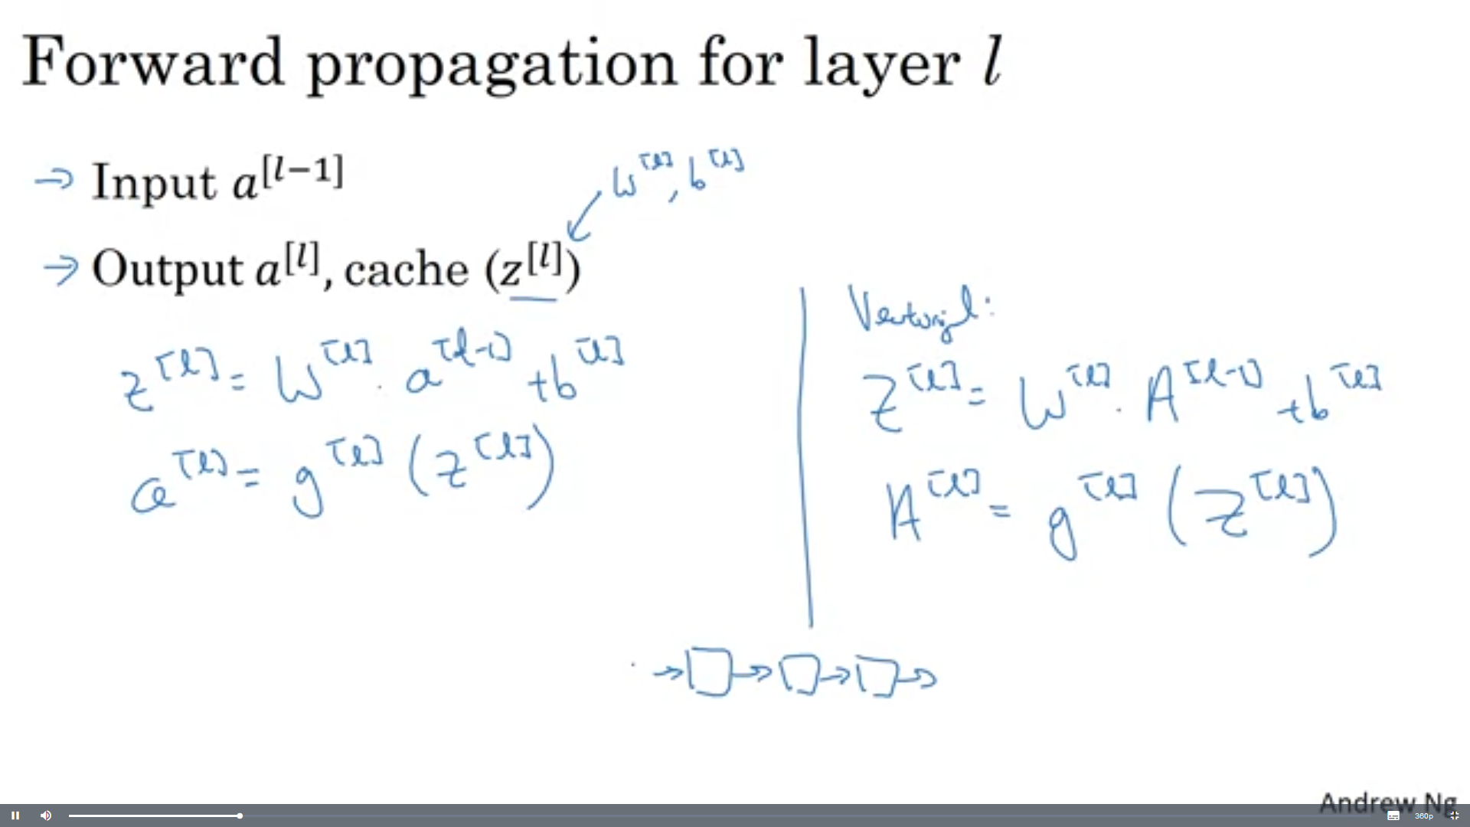
  + 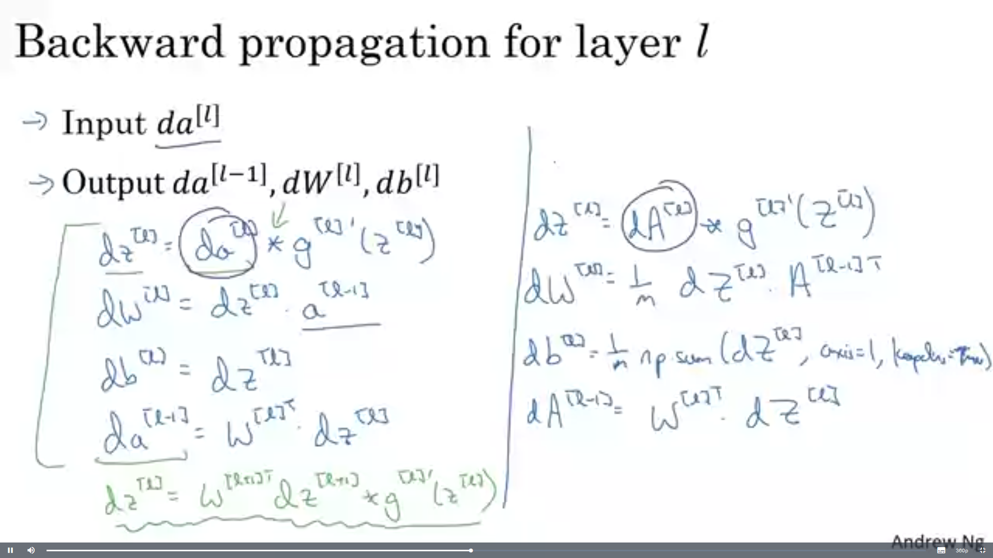
  + 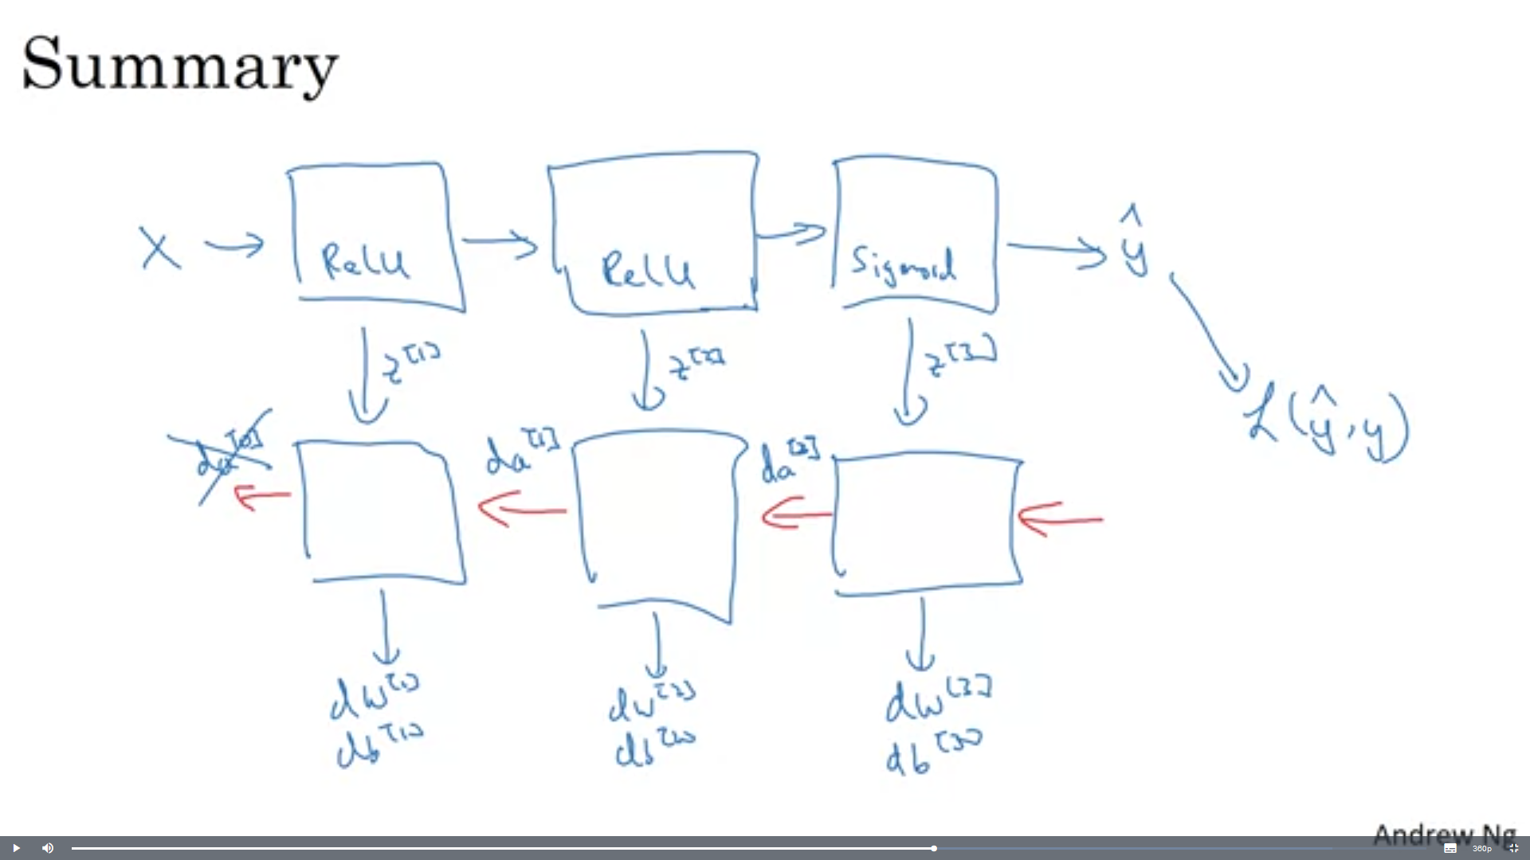
  + When doing forward propagation, you would save your cache as you go
  + Then compute the activation function and feed into the next layer
  + Finally getting the output, then computing the loss function
  + Feed back the loss function and relate the cache to the loss function and recalculate
  + After all of the layers i
* Backward propagation
* Convolutional neural networks
  + Features
  + Edge detection
  + Edges
  + Edge models
  + Characterizing edges
  + Derivatives and average
    - Discrete derivative
    - Finite difference
    - Derivative in 2-d
    - Derivative of images
* Vertical edge detection
* Horizontal edge detection
* Sobel filter
* Scharr filter
* Using convolution to pick a filter
* Padding
* Convolutions on an RGB image
* Multiple filters for RGB image
* ConvNet
  + A convolutional layer of CNN
  + Sequence of convolution layers interspersed with activation functions
* Know parameters you’ll have in a conv layer with 10 filters that are 3x3x20 dimensional each
* ConvNet common layers
  + Learned layers
    - Convolutional layer
      * Is just the dot product of several pixels to make into a smaller size
    - Fully connected
    - Locally connected
  + No learned parameters layers
    - Pooling
    - Activation layer
* Pooling layer
  + Max pooling
  + Average pooling
* Activation map
  + If there were 6 5x5 filters then there would need to be 6 separate activation maps
* LeNet-5
* Why should a ConvNet be deep?
* AlexNet
* VGG – 16
* Residual Network
* Residual building block
* ResNet
* 1x1 convolution
* Inception network

Lecture 05

* Convolutions on an RGB image
* Calculate the input/output layers for an image in a ConvNet based on padding size, stride size, and filter size

Lecture 6

* Inception net and 1x1 convolution
  + A 1x1 convolution can shrink parameters or increase based on the size of the filter parameter and whether it’s bigger than the previous one or not
  + 1x1 convolutions are used to compute reducctions before the expensive 3x3 and 5x5 convolutions
  + Also include the use of rectified linear activation
* Classification and localization
  + Is there a turtle in this picture? If yes, localize
* Regression head
* Classification head
* Detection as regression
* Region proposals
* Selective search
* R-CNN (Regions with CNN features)

Other

* Gradient decent optimization
  + Gradient is another word for slope
  + Relates how variables relate to each other
* Hidden layer3.
* Activation
  + Activate at each level of the neural network
  + So a linear line can bend to make the best classification
* Momentum
  + Similar to learning rate in gradient algorithms
  + Momentum helps to know the direction of the next step with the knowledge of the previous steps. It helps to prevent oscillations. A typical choice of momentum is between 0.5 to 0.9.
* Overfitting
  + When there’s too much training and the classifier line gets too close to the parameters
  + This can cause errors if you don’t have enough data since the ones near the line may go in the wrong direction
* Chain rule
  + 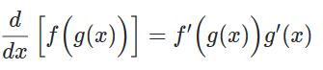
* Transpose of a matrix
  + Flips a matrix over its diagonal.
  + <https://en.wikipedia.org/wiki/Transpose>
* Numpy reshape
  + numpy allow us to give one of new shape parameter as -1 (eg: (2,-1) or (-1,3) but not (-1, -1)). It simply means that it is an unknown dimension and we want numpy to figure it out. And numpy will figure this by looking at the 'length of the array and remaining dimensions' and making sure it satisfies the above mentioned criteria